_______________________’s Unit 3 Lesson 2 Notes The Rock Cycle
- What is rock?
  - Rock is a naturally occurring solid mixture of one or more minerals that may also include organic matter.
  - Most rock is made of minerals, but some rock is made of nonmineral material that is not organic, such as glass.
  - Rocks are always changing through time.
- What processes change rock?
  - Natural processes make and destroy rock. They change each type of rock into other types of rock and shape Earth’s features.
  - Different natural processes influence the type of rock that is found in each area of Earth’s surface.
  - Water, wind, ice, and changes in temperature can change rock in a number of ways.
  - Weathering is the process by which rock is broken down by water, wind, ice, and changes in temperature.
  - Weathering breaks down rock into fragments called sediment.
  - Erosion is the process by which sediment is moved from one place to another.
  - Water, wind, ice, and gravity can erode sediments, which are eventually deposited in bodies of water and other low-lying areas.
  - Sediment comes to rest by a process called deposition.
  - Rock that is buried can be squeezed by the weight of rock or layers of sediment above it.
  - At high enough temperature and pressure, buried rock can change into metamorphic rock.
  - In some cases, the rock gets hot enough to melt and form magma, or molten rock.
  - If the magma reaches Earth’s surface, it is called lava.
  - The magma and lava eventually cool to form new rock.
- What are the classes of rocks?
  - Igneous rock forms when magma cools and hardens. It forms on or beneath Earth’s surface.
  - Sedimentary rock forms when sediment from older rocks or minerals that form from solutions get pressed and cemented together.
  - Metamorphic rock forms when pressure, temperature, or chemical processes change existing rock.
  - Each rock class can be divided further, based on differences in the way the rocks form.
  - Sedimentary rock is composed of minerals formed from solutions or sediments from older rock.
  - Sedimentary rocks are named according to the size and type of the fragments they contain.
  - Igneous rock forms from molten rock that cools.
  - As molten rock cools, crystals form. The longer the cooling takes, the more time the crystals have to grow.
  - Igneous rocks that form when magma cools beneath Earth’s surface are called intrusive igneous rock.
  - Igneous rocks that form when lava cools on Earth’s surface are called extrusive igneous rock.
  - Metamorphic rock forms when high temperature and pressure change the texture and mineral content of rock.
  - Metamorphic rocks are changed by temperature, pressure, temperature and pressure combined, or fluids or other chemicals.
- What is the rock cycle?
  - Over millions of years, any of the three rock types can be changed into another of the three types.
  - The series of processes by which rock changes from one type to another is called the rock cycle.
  - A rock’s identity can be changed by factors such as temperature, pressure, weathering, and erosion.
  - Igneous rock that is exposed can break down into sediment. Beneath Earth’s surface, it can change into metamorphic rock.
  - With temperature and pressure changes, sedimentary rock can become metamorphic rock, or it may melt and become igneous rock.
  - Under certain temperature and pressure conditions, metamorphic rock can melt and form magma, or form a different metamorphic rock.
  - 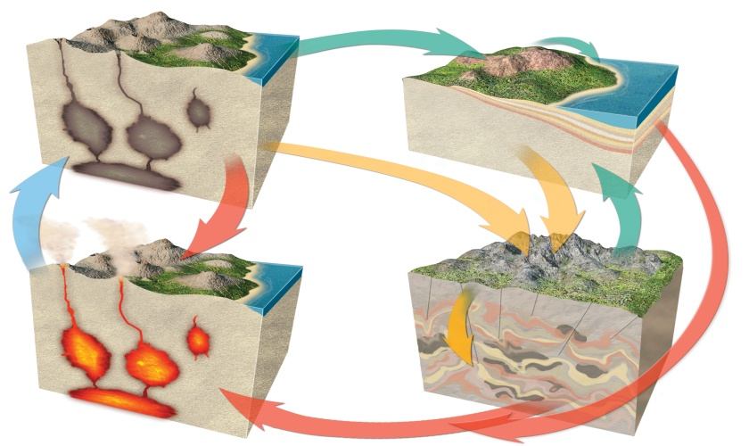
- How do tectonic plate motions affect the rock cycle?
  - Tectonic plate motions can move rock around, leading to changes in the rock. These plate motions can move rock up or down.
  - Uplift is the rising of regions of the crust to higher elevations, increasing the rate of erosion.
  - Subsidence is the sinking of regions of the crust to lower elevations, producing basins where sediment is deposited.
  - A rift zone is a set of deep cracks that form between two tectonic plates that are pulling apart.
  - Blocks of crust in the center of the rift zone subside, and rock below Earth’s surface rises up.
  - The rocks in the middle of a rift zone subside, leaving scarps that can be eroded.
  - Sometimes the decrease in pressure at a rift zone causes magma to form and solidify.

