Earth Unit 4 Lesson 2- Plate tectonics
- What evidence suggests that continents move?
  - In the late 1800s, Alfred Wegener proposed his hypothesis of continental drift.
  - According to this hypothesis, the continents once formed a single landmass, broke up, and drifted.
  - Several lines of evidence support Wegener’s hypothesis.
  - Fossils of the same species are found on continents on separate sides of the Atlantic Ocean.
  - The locations of mountain ranges and rock formations and evidence of ancient climatic conditions also support Wegener’s hypothesis.
- What is Pangea?
  - About 245 million years ago, the continents were joined in a single large landmass called Pangaea.
  - About 200 million years ago, a large rift formed and Pangaea began to break into two continents, Laurasia and Gondwana.
  - Then, Laurasia began to drift northward, and a new rift separated Laurasia into the continents of North America and Eurasia.
  - At the same time, Gondwana also broke into two continents.
  - One continent contained land that is now the continents of South America and Africa.
  - The other continent contained land that is now Antarctica, Australia, and India.
- What discoveries support the idea of continental drift?
  - For many years, scientists did not accept Wegener’s ideas because they could not determine how continents moved.
  - In the mid-1900s, scientists began mapping the sea floor and discovered huge, underwater mountain ranges called mid-ocean ridges.
  - The discovery of mid-ocean ridges eventually led to the theory of plate tectonics, which built on some of Wegener’s ideas.
  - Rock samples from the sea floor revealed that the youngest rock is closest to the ridge, while the oldest rock is farthest away.
  - Even the oldest oceanic crust is young compared to continental crust.
  - Also, sea-floor rock contains magnetic patterns.
  - To explain the age and magnetic patterns of sea-floor rocks, scientists proposed a process called sea-floor spreading.
  - In this process, molten rock from inside Earth rises at the ridges and forms new oceanic crust.
  - Older crust is pushed away from the ridge, and the sea floor slowly spreads apart.
  - Scientists also discovered huge trenches in the sea floor where oceanic crust sinks into the asthenosphere
  - Older crust is thus being destroyed at the ocean trenches at the same rate as new crust is forming at the ridges.
  - In this manner, Earth remains the same size.
- What is the theory of plate tectonics?
  - Scientists began to form a new theory to explain continental drift, mid-ocean ridges, and sea-floor spreading.
  - Plate tectonics is a theory that describes large-scale movements of Earth’s lithosphere.
  - It explains how and why features in Earth’s crust form and continents move.
- What is a tectonic plate?
  - The lithosphere is divided into pieces called tectonic plates, which move around on top of the asthenosphere.

- What are three types of plate boundaries?
  - Plate boundaries may be on the ocean floor, around the edges of continents, or even within continents.
  - The three types of plate boundaries are convergent boundaries, divergent boundaries, and transform boundaries.
  - Each type is associated with characteristic landforms.
  - Convergent boundaries form where two plates collide. This can happen in three ways, depending on the types of crust involved.
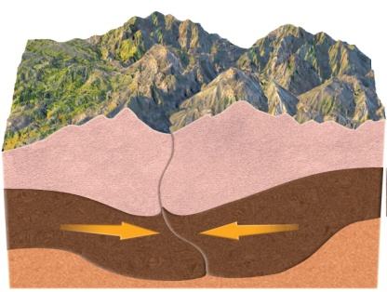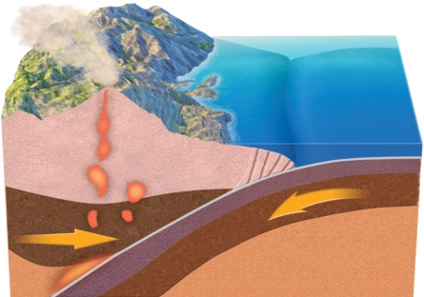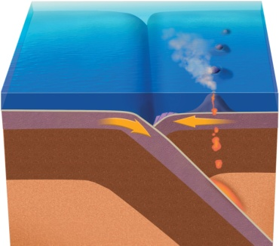
  - At a divergent boundary two plates move away from each other, and magma rises to form new lithosphere at mid-ocean ridge.
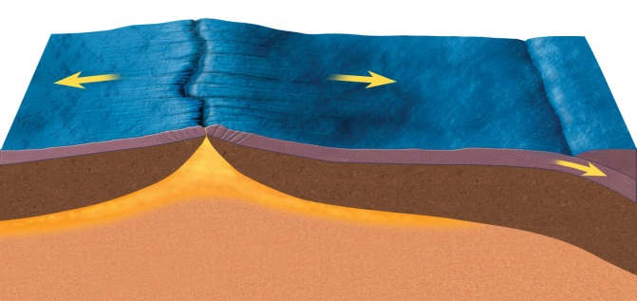
  - A boundary at which two plates move past each other horizontally is called a transform boundary At transform boundaries, the motion of the two plates often produces earthquakes.
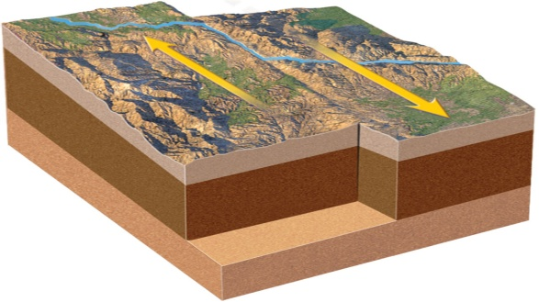
- What causes tectonic plates to move?
  - Scientists have proposed three mechanisms to explain how tectonic plates move: mantle convection, ridge push, and slab pull.
  - Hotter parts of the mantle rise as cooler, denser parts sink. This kind of movement of material due to differences in density is called convection
  - Mantle convection drags the overlying tectonic plates.
  - The mechanism called ridge push moves plates away from mid-ocean ridges as rock cools and becomes more dense.
  - Newly formed rock at a mid-ocean ridge is warm and less dense than older, adjacent rock, which slopes downward away from the ridge.
  - As the newer rock cools and becomes denser, it moves down the slope, pushing the rest of the plate away from the mid-ocean ridge.
  - In the mechanism called slab pull a plate moves because it is pulled along when its denser edge sinks beneath Earth’s surface.
  - The leading edge of a sinking plate is colder and denser than the mantle, so it sinks. The rest of the plate follows.
  - Many scientists think slab pull is the most important mechanism driving plate motion.

