Earth Unit 4 Lesson 3 Mountain Building

1. How can tectonic plate motion cause deformation?
   1. The movement of tectonic plates causes stress on rock structures.
   2. Stress is the amount of force per unit area that is placed on an object.
   3. When a rock is placed under stress, it deforms, or changes shape
   4. Deformation is the process by which rocks change shape when under stress.
   5. When rocks bend, folds form; when rocks break, faults form.
2. What are two kinds of folds?
   1. Folding occurs when rock layers bend under stress. The bends are called *folds*.
   2. Scientists assume that all rock layers start out as horizontal layers deposited on top of each other over time.
   3. A fold, or bend, in the rock layers means that deformation has happened.
   4. Two common types of folds are synclines and anticlines.
   5. In a syncline, the youngest layers of rock are at the core of the fold. The rock layers are usually arched upward, like a bowl.
   6. In an anticline, the oldest layers of rock are at the core of the fold. The rock layers are usually arched downward.
   7. 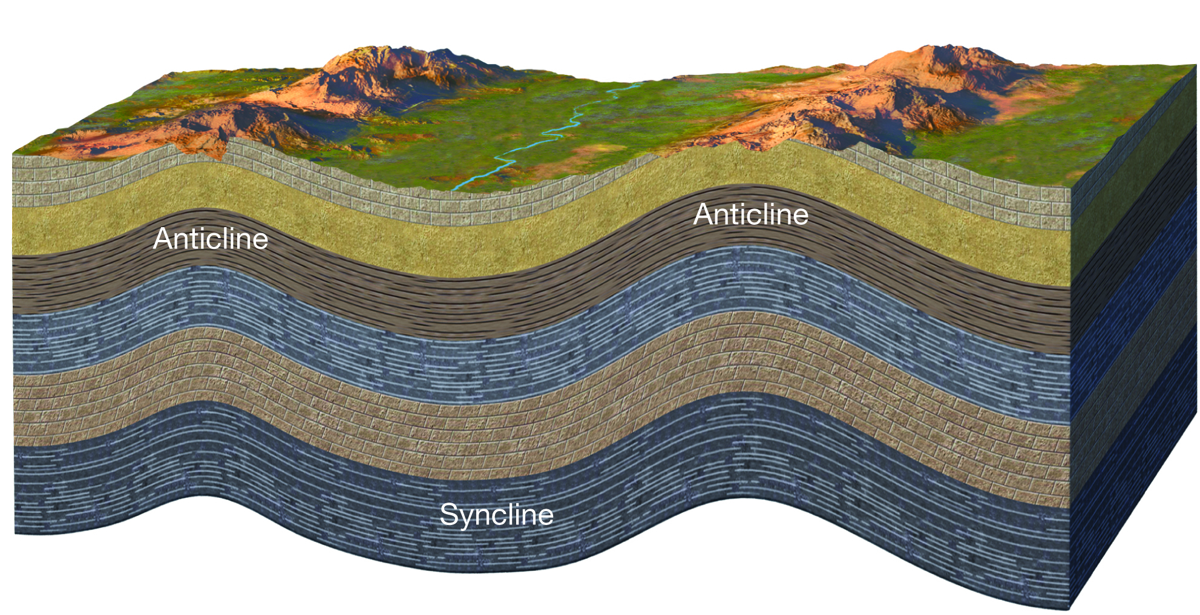
3. What are three kinds of faults?
   1. Sometimes rock is under so much stress that it breaks.
   2. A crack called a faultforms when large blocks of rock break and move past each other.
   3. The blocks of rock on either side of a fault are called fault block. The movement of faults can create mountains and other landforms.
   4. The three main kinds of faults are strike-slip faults, normal faults, and reverse faults.
   5. A fault plane is the location where two fault blocks meet.
   6. For any fault except a perfectly vertical fault, the block above the fault plane is called the hanging wall. The block below the plane is the football.
   7. In a strike slip fault, the fault blocks move past each other horizontally.
   8. Strike-slip faults form when rock is under shear stress or stress that pushes rocks in parallel but opposite directions.
   9. Strike-slip faults are common along transform boundaries, where tectonic plates move past each other.
   10. In a normal fault, the hanging wall moves down relative to the footwall, in a way you would *normally* expect as a result of gravity.
   11. Normal faults form when rock is under tension, which is stress that stretches or pulls rock apart.
   12. Normal faults are common along divergent boundaries.
   13. In a reverse fault, the hanging wall moves up relative to the footwall.
   14. Reverse faults form when rocks undergo compression, which is stress that squeezes or pushes rock together.
   15. Reverse faults are common along convergent boundaries, where two plates collide.
   16. 
4. What are three kinds of mountains?
   1. Mountains can form through folding, volcanism, and faulting.
   2. Uplift, a process that can cause land to rise, can also contribute to mountain building.
   3. Because tectonic plates are always in motion, some mountains are constantly being uplifted.
   4. Folded mountains form when rock layers are squeezed together and pushed upward.
   5. Most folded mountains form at convergent boundaries where plates collide.
   6. Volcanic mountains form when melted rock erupts onto Earth’s surface.
   7. Many volcanic mountains are located at convergent boundaries.
   8. Volcanic mountains can form on land or on the ocean floor.
   9. Fault-block mountains form when tension makes the lithosphere break into many normal faults.
   10. Along the faults, some pieces of the lithosphere drop down compared with other pieces.
   11. The pieces left standing form fault-block mountains.