Unit 4 Lesson 4 Volcanoes Notes
- What is a volcano?
  - A volcano is any place where gas, ash, or melted rock come out of the ground.
  - Many volcanoes are dormant, meaning an eruption has not occurred in a long period of time.
  - Volcanoes form as rock below Earth’s surface melts. The melted rock, called magma, is less dense than solid rock, so it rises to the surface.
  - Lava is magma that has reached Earth’s surface. Lava and ash erupt from a vent, or an opening of a volcano.
  - 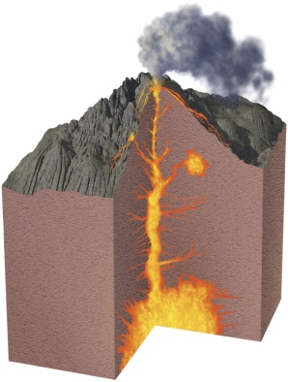
- What are the kinds of volcanic landforms?
  - The location of a volcano and composition of magma determine the type of volcanic landforms created.
  - Volcanic landforms include shield volcanoes, cinder cones, composite volcanoes, lava plateaus, craters, and calderas.
  - Volcanic mountains are built from materials ejected from a volcano.
  - The shape and explosiveness of a volcano depend on the lava’s viscosity, or resistance to flow.
  - Pyroclastic material, or hot ash and bits of rock, may also be ejected into the atmosphere.
  - Shield Volcanoes
    - Shield volcanoes are volcanoes with broad bases and gently sloping sides.
    - They are the result of mild eruptions.
    - 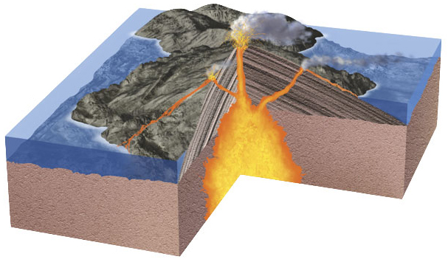
  - Cinder cones
    - Cinder cones are small volcanoes with steep slopes.
    - They form from ash and pieces of solidified lava that fall around a small vent.
    - 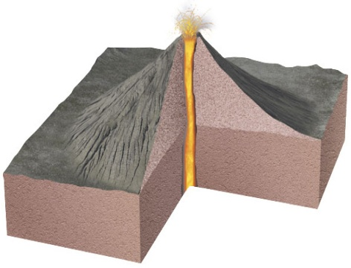
  - Composite Volcanoes
    - Composite volcanoes are built from alternating layers of hardened lava flows and pyroclastic material.
    - They generally develop into large, steep mountains.
    - 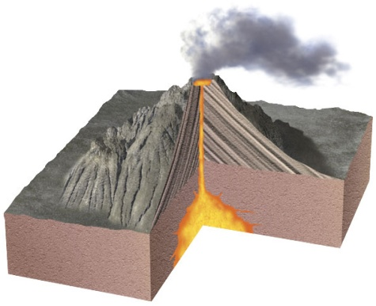
  - Fissures
    - Fissure eruptions happen when lava flows from giant cracks, or fissures, in Earth’s surface.
    - Because fissures have no central opening, lava flows out the entire length of the fissure.
    - Fissure eruptions produce a flattened layer of cooled lava called a lava plateau.
  - Craters
    - A volcanic crater is an opening or a depression at the top of a volcano.
    - A crater is caused by eruptions.
  - Inside the volcano, molten rock can form an expanded area of magma called a magma chamber
  - When the magma chamber empties, the roof of the chamber can collapse, leaving a large basin-shaped depression called a caldera.
  - 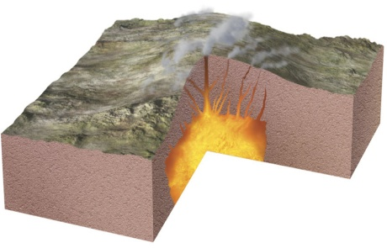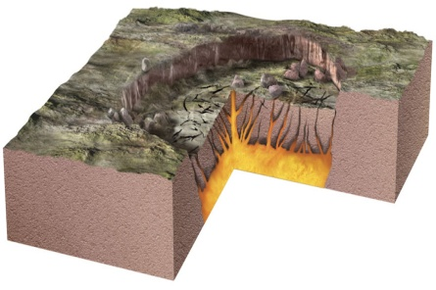
- Where do volcanoes form?
  - Tectonic plates are giant sections of lithosphere on Earth’s surface. Volcanoes can form at plate boundaries or within the middle of a plate.
  - At divergent plate boundaries, where two plates are moving away from each other, fissure eruptions are likely to occur.
  - At hot spots, which are far from any plate boundaries, shield volcanoes, fissure eruptions, and cinder cones can occur.
  - Convergent plates
    - At convergent plate boundaries, composite volcanoes can occur.
    - Composite volcanoes produce the most violent eruptions.
    - The Ring of Fire is a name for the numerous explosive volcanoes that form on convergent plate boundaries surrounding the Pacific Ocean.
  - Divergent plates
    - At divergent boundaries, the crust stretches and gets thinner.
    - As a result, the pressure on the mantle rock below decreases, and magma rises through fissures in the lithosphere.
    - Divergent plate boundaries create fissure eruptions and shield volcanoes.
    - Most divergent boundaries are on the ocean floor. When eruptions occur in these areas, undersea volcanoes develop. These volcanoes and other processes lead to the formation of a long, underwater mountain range known as a mid-ocean ridge.
    - When a divergent boundary is located in the middle of a continent, the crust stretches until a rift valley is formed.
    - 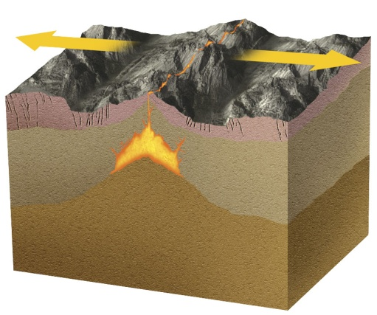
  - At convergent boundaries, one plate usually sinks beneath the other. The mantle above the sinking plate can melt to form magma.
  - The magma rises to the surface and forms volcanoes.
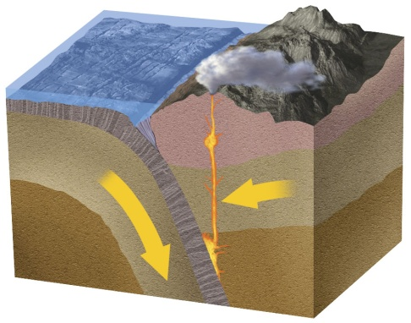
  - Magma at convergent boundaries has a high concentration of fluids, which form gas bubbles.
  - Because the magma has a high viscosity, the bubbles cannot escape easily. As the bubbles expand, the magma rises faster.
  - Eventually, the magma erupts explosively, forming composite volcanoes or calderas.
  - Hot spots are locations far from plate boundaries where a mantle plume, a column of extremely hot mantle rock, rises and produces volcanoes.
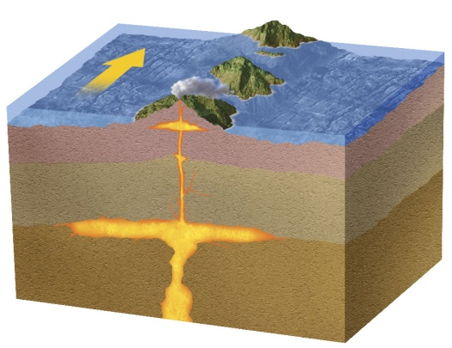
  - Chains of volcanoes can form over time as a tectonic plate moves over a mantle plume.
- Living Near a Volcano
  - Many people around the world live near a volcano because the surrounding soils are fertile for growing a variety of crops.
  - Volcanic rocks can be used in making jewelry, concrete, water filtration systems, and other applications.
  - However, an eruption can produce destructive earthquakes, fire, ash, and lava flows, destroying property and taking lives.

