Unit 4 Lesson 5 Earthquakes
- What is an Earthquake?
  - Earthquakes are ground movements that occur when blocks of rock in Earth move suddenly and release energy.
  - The energy is released as seismic waves that cause the ground to move.
  - The focus is a place within Earth along a fault where the first motion of an earthquake occurs.
  - The place on Earth’s surface directly above the focus is called the epicenter.
  - Seismic waves flow outward from the focus in all directions.
- What Causes Earthquakes?
  - Most earthquakes occur near a tectonic plate boundary, which is where two or more tectonic plates meet.
  - The movement of tectonic plates breaks Earth’s crust into a series of faults, which are breaks in Earth’s crust along which blocks of rocks move.
  - The release of energy that accompanies the movement of rock along a fault causes an earthquake.
  - Stress on the rock causes deformation, which is the process by which the rock becomes deformed and changes shape.
  - As the stress on rock increases, the energy stored in it increases.
  - When the stress is released, the rock may return to its original shape.
  - When rock returns to nearly the same shape after the stress is removed, the process is called elastic deformation.
  - The return of rock to its original shape after elastic deformation is called elastic rebound.
- Where do earthquakes happen?
  - At divergent boundaries, tension stress causes normal faults to form. Earthquakes tend to be shallow because the crust is thin.
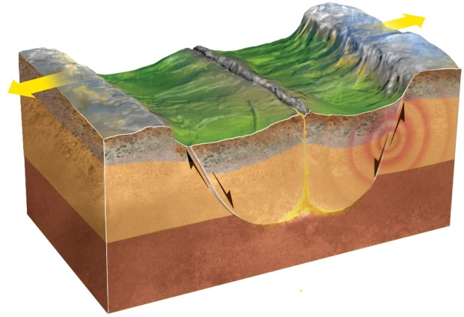
  - At convergent boundaries, rock is squeezed, and the stress is called compression. Reverse faults are formed, and earthquakes can be strong and deep.
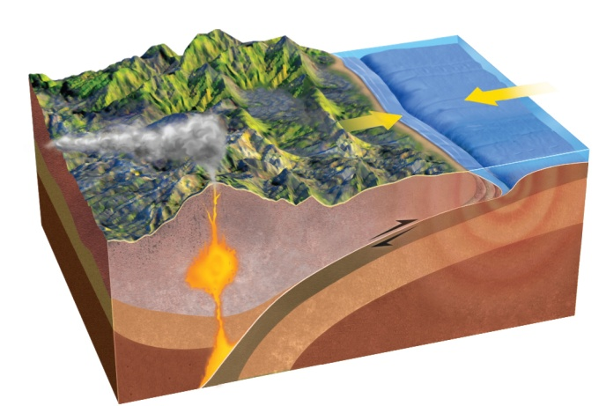
  - At transform boundaries, shear stress pushes tectonic plates in opposite directions. Earthquakes tend to be relatively shallow.
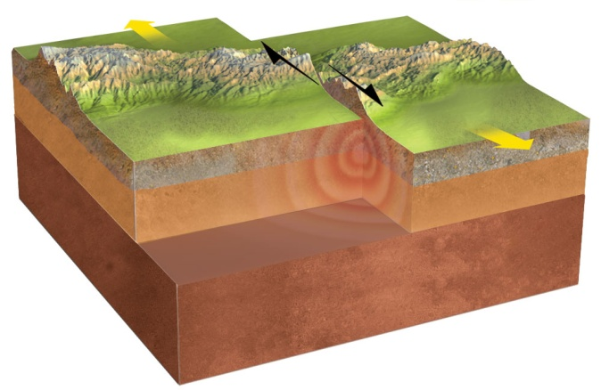
- What are some effects of earthquakes?
  - Most earthquakes do not cause damage, but some strong earthquakes can cause major damage and loss of life, especially in areas closest to the epicenter.
  - When the shaking of an earthquake is more than structures can withstand, major destruction can occur.
  - Much of the injury and loss of life after an earthquake is caused by structures that collapse.
  - An earthquake under the ocean can cause a vertical movement of the sea floor, displacing an enormous amount of water and generating a tsunami.
  - A tsunami is a series of extremely long waves that can travel across the ocean at speeds of up to
800 km/h.
  - As the waves reach the shoreline, the height of the waves increases. The huge waves can cause major destruction.
- Killer Quake
  - In 2004, an earthquake generated a tsunami that wiped out half the population of Banda Aceh, Indonesia.
  - The tsunami traveled outward from the epicenter in the Indian Ocean. Banda Aceh was very close to the epicenter.
  - The destruction to parts of Asia was so massive that geographers had to redraw the maps of some countries.

