________________________________________________’s Notes on Plant Processes
- How do plants obtain and use energy?
  - Plants use photosynthesis to change light energy to chemical energy in the form of sugar.
  - Plant cells have organelles called chloroplasts where photosynthesis takes place.
  - Chloroplasts are made up of two membranes that surround stacks of smaller, circular membranes that contain chlorophyll, a green pigment.
  - Chlorophyll absorbs light energy from the sun.
  - Sunlight is made up of various wavelengths of light. Different wavelengths of visible light are seen as different colors.
  - Chlorophyll absorbs many wavelengths, but it reflects more green light than it reflects other colors of light. As a result, most plants look green
  - The light energy captured in chloroplasts is changed and stored in the bonds of a sugar called glucose.
  - In the same process, oxygen gas is released.
  - In plants, extra glucose is stored as starch or changed to other types of sugar such as fructose or sucrose.
  - In cellular respiration, cells use oxygen to release stored energy from the bonds of sugar molecules. This occurs in organelles called mitochondria.
  - Cellular respiration also produces carbon dioxide and water.
- What are the phases of a plant’s life?
  - All plants complete their life cycle by alternating between two phases: the sporophyte and the gametophyte.
  - In one phase, plants called sporophytes produce spores by meiosis. The spores are then released.
  - Meiosis is a process of cell division in which each daughter cell receives half the chromosomes of the parent cell.
  - Under the right conditions, spores grow into plants called gametophytes.
  - Female gametophytes make eggs and male gametophytes make sperm.
  - When a sperm fertilizes an egg, they form an embryo, which develops into a seed. The seed is released and can grow into a new sporophyte.
  - 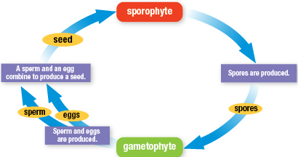
- How do seedless plants reproduce?
  - In seedless plants, sperm, which have tails and swim to eggs to fertilize them, are released in the presence of water.
  - The fertilized eggs grow into sporophytes.
  - Some seedless plants, such as mosses, have a visible gametophyte phase.
- How do seed plants reproduce?
  - In most seed plants, the sporophyte makes two types of spores, male and female, that grow into microscopic male and female gametophytes.
  - The male gametophyte is pollen, a tiny structure where sperm forms, which can be carried by wind, water, or animals.
  - The female gametophyte produces eggs. Pollination happens when pollen lands on and fertilizes the female plant reproductive structure.
- How do flowering plants reproduce?
  - Flowers are reproductive structures with specialized leaves called sepals and petals, which can attract animal pollinators such as insects.
  - A stamen is the male reproductive structure of flowers. At the tip of each is an anther, where pollen is produced.
  - A pistil is the female reproductive structure of flowers. When pollen reaches the tip of a pistil, called the stigma, pollination occurs.
  - A pollen tube grows down through the pistil into the ovary, where one or more ovules contain eggs.
  - Sperm travel into the ovary and fertilize the eggs, which develop an embryo: a tiny, undeveloped plant.
  - The ovule develops into a seed that surrounds and protects the embryo. The ovary becomes a fruit, which protects the seeds and helps them spread.
  - 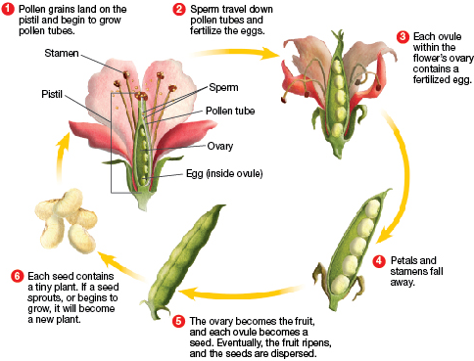
- How do plants reproduce asexually?
  - Asexual reproduction allows a plant to reproduce without seeds or spores. Part of a parent plant, such as a stem or root, produces a new plant.
  - Plantlets, tubers, and runners are examples of structures that plants use to reproduce asexually.
  - Plantlets grow on the edges of a plant’s leaves. They fall off and grow on their own.
  - Tubers, such as a potato, are underground stems that store nutrients and grow into a new plant.
  - Runners, such as strawberries, are above-ground stems that can grow into new plants.
- What are some ways plants respond to their environment?
  - Anything that causes a reaction or change in an organism is a stimulus. Plants can respond to internal stimuli, such as water levels in cells.
  - A stoma is an opening in the leaf’s surface which helps a plant exchange gases and respond to its water levels.
  - Stomata are surrounded by two guard cells that open and close the stoma. When open, carbon dioxide enters, and oxygen and water vapor exit.
  - The loss of water from leaves is called transpiration.
  - A plant wilts when it loses more water than it can absorb through roots.
  - When a plant is wilting, its stomata close, preventing further water loss.
  - Plant growth in response to a stimulus is called a tropism.
  - Plant tropisms are controlled by plant hormones, which are chemical messengers that cause changes in cells.
  - A change in the direction of plant growth in response to light is called phototropism.
  - Hormones build up in cells on the shaded side of the stem, causing them to lengthen, which makes the stem bend toward the light.
  - A change in the direction of plant growth in response to gravity is called gravitropism.
  - Most stems grow upward, away from Earth’s gravitational pull, and most roots grow downward, toward the pull of gravity.
  - Dormant describes the inactive state of a seed or other plant part when conditions are not right for growth.
  - Some plants shut down during winter or a dry season, living off of stored sugars.
  - Many plants come out of dormancy in the spring, triggered by more direct sunlight, longer days, and increased rain.
- In Season
  - A plant’s growing season occurs when temperature, light, and water conditions favor growth for that type of plant.
  - Out-of-season produce is grown in a greenhouse or shipped from other parts of the world.

